“Disposal of hard waste”

Introduction:

Hard wastes are larger than regular so quite hard to fit in a regular bin. These are counted as hard or solid waste because way of handling it is different. Items like fridges, washing machines, couches, cupboards, wardrobes, televisions, furniture computers, mattresses, building material and similar items are preferred as solid wastes.

There are mainly 4 types of wastes produced around us:

**Industrial:** Industrial waste contains of the wastes caomes out during manufacturing process by the industries or mills. Most of them are not biodegradable and hard wastes full of chemicals.

**Commercial:** Commercial wastes are from business, sports, entertainment or recreation works which are used for trades.

**Domestic:** Domestic waste means wastes, consisting of combustible materials, such as paper, cardboard, yard clippings, wood, or similar materials, generated in a dwelling, including the real property upon which it is situated, containing four living units or less.

**Agricultural:** Agricultural wastes are produced from agricultural operations That includes farms ,poultry houses, fertilizers and pesticides used in lands for crops.

**They also can be divided in to two types as natures preference:**

**Biodegradable:** These wastes can be easily mixed into soil and also they can sometime help soil to become more helpful for harvest. They can also turn into fossil fuels. Example: wooden wastes, cardboards, papers etc.

**Non-biodegradable:** Non-biodegradables are the major curse to nature as they cant mix with soil or water and cause danger for living animals like fishes in the sea and causing some helpful bacteria and insects to die. Example: plastics, medical wastes, carbon paper etc .

Problem:

Hard waste collection and disposal is a one of the major problem of urban environment in most countries mainly for developing countries worldwide today. Need for Proper management is rising as with growing population and technology advancement. European policy, presently, is pushing to adapt several steps for managements for the sake of nature.

In This case we can find and say there are some problems for our municipals to take care of. These are:

* Inadequate service coverage
* lack of new technology use with conventional ideologies
* lack of recycling activities
* inadequate management of wastes
* not enough awareness in television commercials for it.

A landfill is no longer considered the final solution as the population is growing and lands are decreasing ,the areas are becoming more congested as the moisture from the waste landfill is coming to urban areas to create more environmental pollution. So proper management can be helpful to valorize the wastes. These materials can be either as a source of energy (Waste-to-Energy) or as a product (Waste-to-Product). It has been estimated by UNEP (United Nations European programme) that solid waste management contributes for the greenhouse gases (GHGs) emission between 3 and 5%. This is mainly due to the emission of CH4, CO2, and N2O that escapes from the open dumps or open landfills. Open landfills should be used as temporary storage for short time.

Increased population causing solid wastes in urban cities affecting badly on the sanitary related problems such as sanitation facilities, water supply, waste management, and transport infrastructure.

In local population some studies gave evidence that solid waste management facilities has impact on child birth as the child weight is lower where the problem is more also few types of cancer and other diseases are forming around in the places where less solid waste management is done.

The plastics waste disposal is a major global environmental problem. As plastics are essentially hydrocarbons, they possess a calorific values ranged between 30 and 40 MJ/kg. They can be burned or recycled using heating or thermal therapies.

A separation between organic and non-organic waste is necessary before going for management for an effective energy generation. The EPA estimated the amount of solid waste generation in the United States with 254 million tons in 2013.

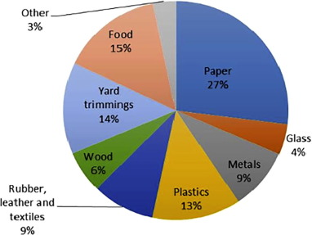

Figure: Composition and classification (by material) of MSW generated by the United States in 2013 .

Management of wastes(solution):

Some solutions according to different countries or places:

We can see today’s technology advancement is highly appreciated and can help for solid managements in various ways which can be little more expensive but this will be better because if the environment gets polluted it will be hazardous for mankind and of course far more expensive.

Our municipals can take some easy steps like there is a critical absence of dustbins in the local colonies and slums which produce more hard wastes because they barely know about disposals. We should aware them of the facts and also make free door to door waste collection service for them specially. There are also various seasons that differs the hard waste management. We should make more special efforts for the moist weathers to clean the landfills quicker.

The most trending is a report by UNEP (United Nations Environment Programme ) that the internationally recognized institutions recommended a future waste management focused on the 3R concept (namely: Reduce, Reuse, and Recycle).

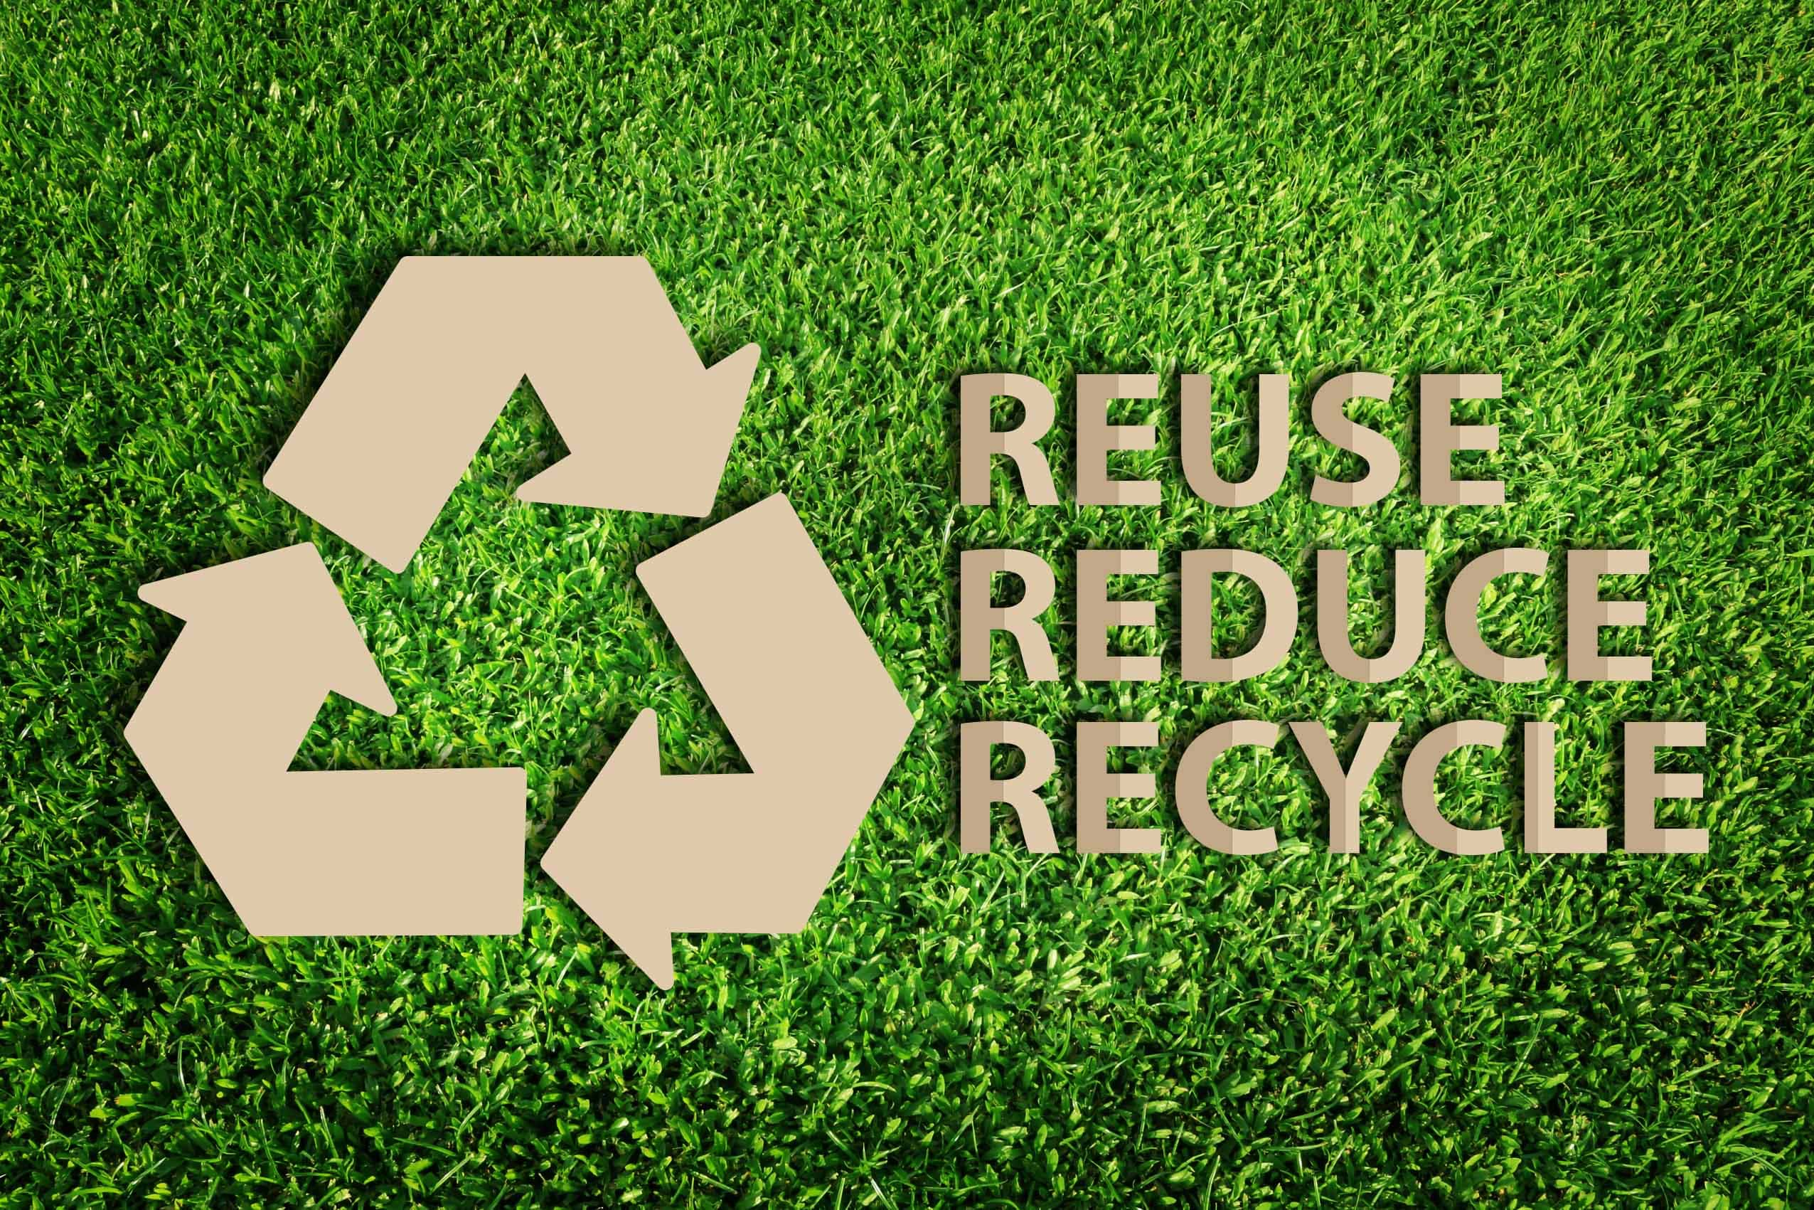

Researcher Riber et al. mentioned that depending on his research that developed countries are using various methods for management of wastes including compost as in new technology. In this era our technology is advanced and we should make the best use of it.

**White biotechnology:**

Well known for lab use organic chemicals can be generated from organic waste via bio-refinery or white biotechnology as well as developing sustainable green production strategies.

**Flow chemistry methodologies:**

Flow chemistry is well known to be used in industries for various processing methodologies, it still can be used in biomass solid waste/valorization. The limitation here is they can cause more biopolymers and compounds that are highly stable.

**Microwave irradiation:**

Microwave irradiation can also be a technique for any solid waste transformation.

**Pyrolysis:**

Further valorization strategy is related to employing pyrolysis in the synthesis of energy or fuels. This strategy involves heating of the biomass at high temperatures in the absence of air to produce the required decomposed products.

**Thermal applications:**

As we know plastic waste as great threat but destruction of plastic waste is possible by thermal applications. The application of thermal or burning the plastic can be a source of making carbons and is replacing fossil fuels.

**Anaerobic digestion:**

Valorization of sludge from wastewater treatment plant for biogas production via anaerobic digestion also is a useful idea.

Modern technologies like Evo-Eco and one plus systems also are new innovations.

**Trash Smarter with Evo-Eco**

Basically, on the list of fancy garbage cans is the Evo-Bin from Evo-Eco. This new innovation tells you in your trashbin which item can be recycled, trasged and composted. A scale in this system detects and changes in weight and sends a message on the slides. This smart waste system offers a dynamic, educational experience designed to reward users for responsible waste disposal.

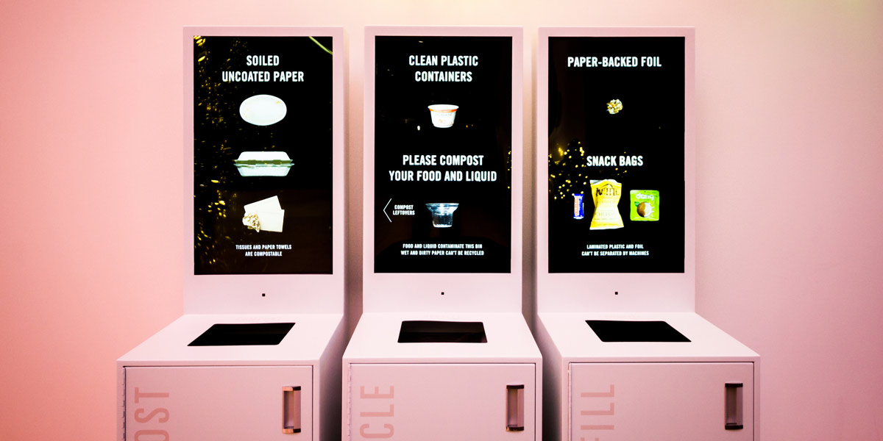

**A monitor with one plus system:**

A monitor that analyses about the dustbins if they are already full or not and how much full . It has ability to sense the capacity of a trash bin with its ultrasonic sense that helps the tracker to schedule times and helps them manage the costs.

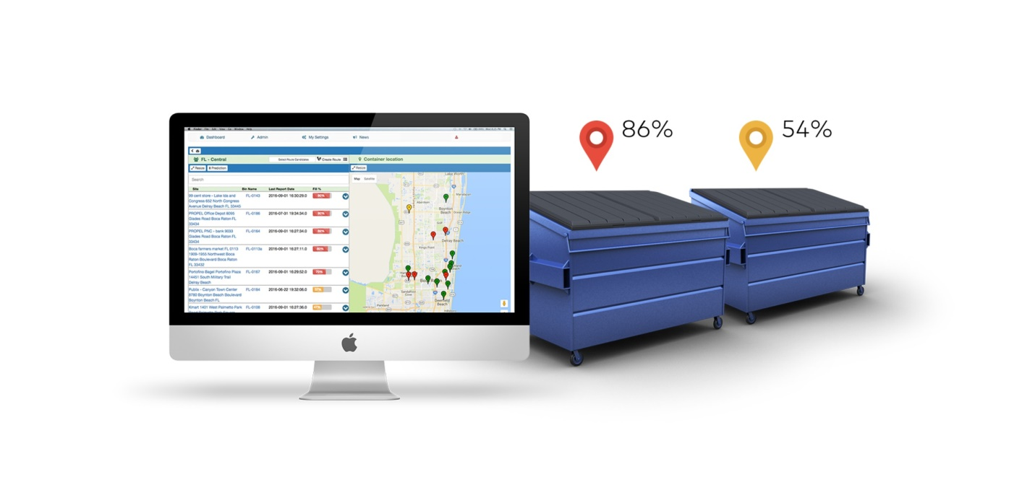

**Except**, the chemical usage we can make campaigns for solutions in the universities and other mass or local areas for the proper guidance of giving away the solid wastes to recycling companies who make new innovations using them.

Students can make recycling campaigns for a week or so to recycle some products like glasses can be recycled but most of the glass bottles of juices end up in trash. There are various problems with plastics but plastics can be refabricated and made blocks with that we can clog the water in times of cyclone and also make roads with the blocks. We can also pickup cigarettes and make them reuse as the toxins in cigarettes are harmful for environment. There are also so many innovative ideas that students can use in the campaigns for hard waste management.

In various countries government also takes initiative of gathering the solid wastes from locals once or twice a year and make them use in different ways. These should be more advertised as many people doesn’t know about it much.

An innovative way or solution is to make an application in our hand phone to click and call the recycling companies to take the solid wastes from the local people as it will also make people more comfortable and there will be new job opportunities for the people for this initiative.

Content:

The main content of the problem hard waste disposal is the management of the hard wastes. It depends on the way each countries manage it. For the developing countries it is much more challenging than the developed countries. The developing countries are also in lack of financial resources than the developed countries and they have technology developing so more wastes coming out. The landfill must be managed more effectively as these can also make the environment polluted in many ways.

A great waste management provider does more than just empty your bins. They must be service and material experts. From coordinating the right schedule for business and budget for a preferable setup can minimise waste problem and maximise recovery. A waste management provider should be looking for solutions that increase sustainability from the supply chain to design, manufacturing and disposal.

Feasibility of solutions:

A feasible solution is a proposed solution which evaluates whether it is possible or not in general term.

In many emerging and upcoming economies, the amount of waste generated is rising sharply. Waste management capacities for the lands we are using is becoming lower in numbers. In the further development of economy it can be a problem if we dont upgrade it in feasible ways. Our economic growth depends on the management we are making for the nation.

To use investments wisely, the suitable technologies must be chosen as the circumstances carefully. This totally depends on factors such as recycling potentials, reliability, operational cost, investment levels and other national and international regulations. It’s an expert area, and understanding waste management and waste to energy technology requires specialist support.

We can make 3 sectors on feasibility of solution as it depends on the nation how they should carry it.

1st sector is Choosing the Right Technology:

- conventional and alternative technology solutions

- heat outsourcing possibilities

- anaerobe digestion

- improving performance of existing installations

- cost management

2nd sector is Tailored support:

- Determining a benchmark for waste management technology

- Client/lenders support during tendering

- Performance review

- Feasibility study reports

- Tender support documents

3rd sector is Global reach and local understanding:

* Students can make campaigns
* locals can be aware of the fact when to give away the solid wastes
* people can use technology like modern applets to click and call the recycling companies to take the wastes.
* particular region or market should be chosen for the waste management works
* global activities and decisions can be helpful.

Conclusion:

In our developing era convention ideas needs to be used with modern ideas .For our government as well as municipal it is a challenge in todays world. Our municipals must try to gather the solutions before it gets too late. The process of management of solid waste is actually a combination of collection, sorting and segregation, transportation, and finally disposing off of wastes. But the actual management of solid waste starts from the generation point. The rate of generation of the solid waste is not uniform all around the world. Even in an area it varies from season to season. Our technology advancement shows us that the solid wastes can be taken as resources for future goods instead of burden. The last conventional way landfill must be used for short time storage as our nature is now on alarming stage. As nearly half of the waste is biodegradable they are easy to manage for the technology we got. Our unplanned slums and colonies produce more hard waste we should take care of them. Our mass and local citizens must be aware of the fact of hard disposal problem the country facing for implementing the solutions .

Therefore, the present study despite its limitation has been successful in highlighting the solid waste management status of the world with its innovative solutions.

Reference:

<https://www.sciencedirect.com/science/article/pii/S1110062118301375>

<https://www.clf.org/blog/municipal-solid-waste-is-a-problem/>

<https://www.sustainablesanantonio.com/practices-technology/reduce-reuse-recycle/>

<https://datatopics.worldbank.org/what-a-waste/trends_in_solid_waste_management.html>